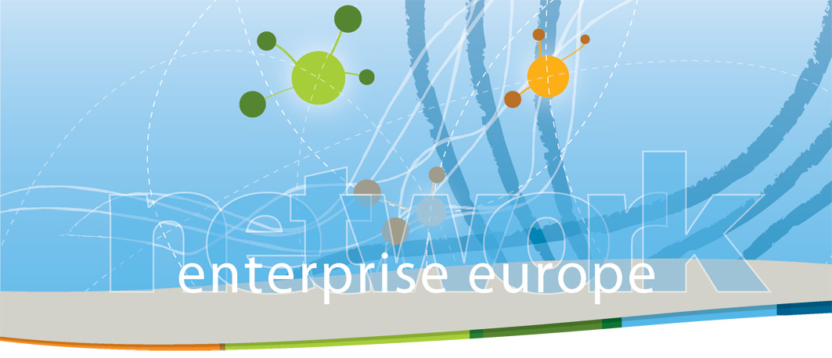

Opportunità di ricerca partner
per partecipare a progetti europei,

in particolare nell’ambito del 7° Programma Quadro di Ricerca e Sviluppo

Tramite la rete Enterprise Europe Network è possibile individuare partner per partecipare ai progetti europei – in cui uno dei requisiti fondamentali è la TRANSNAZIONALITA’ – sia ricercando partner per una proposta da presentare, sia proponendo le proprie competenze per essere selezionati come partner nell’ambito di una proposta progettuale presentata da altri.

Ecco una selezione di ricerche e offerte di partenariato provenienti dalla rete Enterprise Europe Network. Per manifestare interesse a qualcuna di esse e richiederne i contatti e maggiori dettagli, inviare una e-mail a simpler@ra.camcom.it specificando il codice di riferimento (ex: Ref: CY 1-0410).

Per diffondere a vostra volta le vostre ricerche partner o i vostri profili per proporsi come partner, compilare in inglese i relativi moduli (per i “keywords” – ambiti di competenza - vedi la lista annessa) e inviarli allo stesso indirizzo e-mail.

Per info: EUROSPORTELLO-Camera di Commercio di Ravenna (Simpler)
Paola Saiani, tel. 0544-481464,fax: 0544-218731, simpler@ra.camcom.it

APRILE 2010

- CY Lefkosia (Ref: CY 1-0410)

Partner search ICT-PSP 4 INSTRUMENT: PILOT B

We are currently preparing a proposal under call 4 for ICT-PSP: instrument Pilot B under Theme 2.3: Digitizing Content For Europeana. RTD Talos, Network Partner for BSC-Cy (EEN Cyprus) is co-ordinator of the project. The project will revolve around the digitization of travel books from the 16th-20th century from the islands of the Mediterranean. The project involves gathering exploration narratives, descriptions of travelling etc, which will be subsequently digitized from another partner of the project- a digitization company- for access on Europeana. A respectable amount of partners has agreed to participate such as foundations with excellent collections, libraries, educational and culture authorities etc.
We are currently looking for a partner who can either contribute to our collections to be digitized or for someone who can offer INTELLECTUAL PROPERTY RIGHTS knowledge so as to be leader of the specific work package. We have received legal advice on the issue of IPR but wish to dedicate an entire WP on the subject in order to ensure best effectiveness.
DEADLINE OF PROJECT: 6th of June 2010

- ES Asturias – FICYT (Ref. ES 2-0410)

Partner search: RENERUNIT

A Spanish company is looking for partners for preparing a proposal under Intelligent Energy Europe Programme 2010 (CIP).
TITLE: “Assessment and Training Unit for the energy efficiency promotion and the use of renewable energies in the building sector and urban transport companies.”
ABSTRACT: The so called RENERUNIT Project aims mainly at two different topics, though clearly compatible in themselves: on the first hand renewable energies at a domestic level, and on the second hand energy efficiency in transport. We mention the compatibility in between both since CO2 and greenhouse gases are targeted as potentially affected by the measures we do herein propose.
DESCRIPTION : The main goal has to do with the founding of a technical-economic assessment unit with also continuous activity in training and dissemination fields, helping by means of the tools below mentioned, to promote the use of renewable and a more conscious freight services at an urban level.

- SK Bratislava (Ref. SK 3-0410)

Search for Projects partners form the Business Faculty

The Business Faculty of the University of Economics in Bratislava, is interested to participate in the FP7 projects (topics: innovation, renewable energy sources, IT).

The University of Economics in Bratislava (UEB), established in 1940 as the Slovak Higher School of Commerce, is one of the most important educational and scientific-research institutions in the Slovak Republic. The UEB consists of six faculties, one of which is also the Faculty of Business Economics with seat in Košice (FBE).
The FBE provides higher education in the field of economics and business in Bachelor’s, Master’s and Doctoral programs for full-time and part-time students. The FBE, within UEB, is a member of various international institutions such as: the EUA – European University Association, the EAIE – European Association for International Education, IUA – International University Association, Magna Charta Universitatum and others. The FBE has been involved in many national and international projects within European Union programs such as Leonardo da Vinci, Erasmus, the European Social Fund, 7FP, Vega, Kega and others. The development of international cooperation with universities, enterprises, and institutions from the whole world is one of the priorities of the FBE.
As science and research form an integral part of the university’s activities, FBE is looking for partners to collaborate in 7th Framework Programme.

- IT Milano (Ref IT 4-0410)

Search for projects: machinery sector

Italian company in the machinery sector is looking for projects.
Abstract of the Profile and expertise offered: Cason operates in three related but different sectors, each of which is of strategic importance in modern industrial production: textiles, electronics and plastics. Cason Spa produces machinery and plant for the textile industry; PCK Srl produces machines for printed circuits; CASPLAST SRL builds extrusion lines for plastic materials.
Constant research into the most effective technology and the development of the most suitable solutions for the construction of machines increasingly in line with the market requirements are complementary factors, and the Group has decided to invest in these areas in a significant, continuing manner.
The personnel working for the Group takes part in constant update programmes, in the form of courses and seminars held both inside and outside the company, enabling them to remain in step with new knowledge and expectations. Their machinery is also kept constantly updated, to enable it to respond to a constantly evolving demand. By investing in research and development, they’re able to keep a large number of fundamental functions of strategic importance for our operations inside the Group, including Software development and mechanical and electronic design.

